**A113 – Mathematics**

**Worksheet for Problem 04: Getting It Straight**

1. Looking at the game and methods of scoring in the problem statement today, list down some of the things you will need to know and strategies you would adopt in order to maximise your chances of winning.

* Gradient of straight lines.
* …

**Visual examination of dots on a straight line StraightLine.xls**

1. Open and use  to answer the following questions.
2. In **Sheet1** of StraightLine.xls, 3 dots (A, B and C) were drawn on the graph with origin O. By observing the 3 dots, determine whether a straight line passes through the **centres** of all the 3 dots.

No, the line doesn’t pass through the 3 dots

1. Click the “Add/Remove Line” button to insert a straight line on the dots to verify your answer to Q2(a).
2. Comment whether it is useful to use visual examination to play this game.
3. Go to **Sheet2** of StraightLine.xls. You will see another 3 dots (P, Q and R).
4. By visual examination, determine whether a straight line passes through the **centres** of all the 3 dots: P, Q and R. Explain.
5. It is easier for us to determine whether a straight line passes through the centres of P, Q and R as compared to that of A, B and C (the 3 dots in Sheet1). What are the differences between these two sets of dots that make one easier to determine than the other? What conclusions can you draw about visual examination?

**Gradient of a straight line**

1. The **gradient** (also called **slope**) of a straight line shows how steep a straight line is. For example, consider the two straight lines in Figure 1 below:

*θa* > *θb*

Line B

Line A

Datum Line

*θb*

*θa*

Figure 1

Line A is steeper than Line B. Therefore, Line A has a larger gradient as compared to Line B.

We will investigate how to use the concept of gradient to determine whether 3 dots are collinear, i.e. whether the 3 dots lie on the same straight line.

1. Go to **Sheet3** of StraightLine.xls. The information in Sheet3 is almost the same as that of Sheet2 except that the position of dot R has been shifted to a new position and is now called Rnew.
2. By visual examination, determine whether a straight line passes through the **centres** of all the 3 dots P, Q and Rnew. Justify your answer.
3. In Sheet2, the distance of PQ is the same as the distance of QR. In Sheet3, the distance of PQ is not equal to the distance of QRnew.

Does the distance between the 2 dots play a part in your analysis to determine whether these 2 sets of dots are collinear? Explain your answer.

1. Using  and  (similar representation is used for all other dots) to represent the *x*-coordinate and *y*-coordinate of dot P respectively, find the values of
   * 1. 
     2. 

The ratio  is commonly known as the gradient of PQ. Likewise, the ratio is the gradient of QRnew.

1. From the values obtained in Q5(c), what can you tell about dots that are collinear and the gradient between any two dots?
2. Repeat similar steps in Q5(c) for the set of dots: A, B and C (in Sheet1) and the set of dots: P, Q and R (in Sheet2).

From your result, summarise the relationships between a set of collinear dots and the gradient between any of the two dots in the collinear set.

1. Using what you have learnt so far, discuss about a strategy to use when you are given three points and want to find out if they are collinear.

**Equation of a straight line**

1. Go to **Sheet4** of StraightLine.xls. In Sheet4, the position of dot R has been shifted to a new position that is out of sight of the graph and is now called Rout. The coordinates of Rout is unknown and it is given as (*,*).
2. If P, Q and Rout are collinear, write down the relationship between PQ and QRout.
3. Express the relationship that you have given in Q8(a) such that  is expressed in terms of . This expression on the relationship between  and  is also known as the equation of the straight line, PQ.
4. You can learn more about finding the equation of a straight line by referring to the file below:



**Parallel and perpendicular lines**

1. Go to **Sheet5** of StraightLine.xls. In Sheet5, two extra dots M and N were added to the existing dots P, Q and R.
2. Using visual examination, determine whether the line passing through P, Q and R is parallel to the line that passes through M and N.
3. Using the idea of gradient as discussed earlier, justify your answer to Q10(a).

Thus, what can you conclude about lines that are parallel?

1. Go to **Sheet6** of StraightLine.xls. In Sheet6, 4 extra scattered dots E, F, G and H were added to the existing dots P, Q and R.
2. Using visual examination, determine which of the scattered dots can be chosen such that a straight line drawn across the selected dot and Q will be perpendicular to the line connecting P, Q and R.
3. Other than using a protractor to assist you to draw a perpendicular line, what other information on the chart can assist you in deciding which dot(s) to choose in Q11(a)?
4. Find the gradient of the line, , connecting the selected dot and Q. Similarly, determine the gradient of PQ, . What do you get when ×?

Thus, what can you conclude when the gradients of two perpendicular lines are multiplied together?

|  |
| --- |
| ***Practice Questions***  *(It is essential to complete these practice questions so that you can understand the concepts of this lesson better and be more confident and competent in handling related questions.)*  Gradient of straight line  Determine the gradient of the line joining the following points:  O (2,1) and X (4,1)  Gradient of OX = =  O (0,0) and Y (0,3)  Gradient of OY = =  Given that the points A, B and C have the coordinates (0, 6), (5, 11) and (2, 3), find the gradients of AB, AC and BC. Are the three points collinear?  Gradient of AB = =  Gradient of AC = =  Gradient of BC = =  Collinear / Not collinear  Using the gradient method, determine if the following sets of points are collinear:  P(-0.5 , 4), Q(-1, 2) and R(10, 45)  P(-0.5, 4), Q(-1, 2), and S(0, 6)  M is the midpoint of the line joining the origin to point P. If the coordinates of M are (3, -2), find the coordinates of the point P.  Coordinates of P =  Equation of straight line  [You may want to watch the following [video](https://docs.google.com/file/d/0BxYqWZfRUFnoUGExc2tzZUcwTWM/edit?usp=sharing) which would help to recap some of the key concepts learnt before attempting the following question.]  Find the equation of the straight lines in Question 1.   1. X (2,1) and Y (4,1) 2. O (0,0) and Z (0,3)     Determine whether the following two pairs of coordinates lie on the straight line     * + 1. coordinate (-8 , 10)   Yes / No   * + 1. coordinate (8 , -10)   Yes / No  Given that the gradient of a straight line is 4 and this straight line passes through the point (6,-2), find the equation of the straight line.  Given that a straight line has equation: . What are the gradient and the *y-*intercept of this line? [hint: Note that the *y-*intercept refers to the distance between the origin and the point where the straight line cuts the *y-*axis.]  Gradient =  y-intercept =  Calculate the value of *k* if the point (*k*, 2*k*) lies on the straight line.  *k* =   1. In the diagram below, the coordinates of point B is (0, 19) and the coordinates of point C is (0, 7). The sloping line that passes through B and the horizontal line that passes through C meet at the point A.   *x*  *y*  B  A  C  O  (0, 7)  (0, 19)   1. Write down the equation of the line AC. 2. Given that the gradient of the line AB is 3, find the equation of the line AB. 3. Calculate the coordinates of the point A. 4. Point A is reflected about the *x*-axis to point D, find the equation of the line BD.   Parallel and Perpendicular lines  [You may want to watch the following [video](https://docs.google.com/file/d/0BxYqWZfRUFnoaXNHNVhtRHNnTDQ/edit?usp=sharing) which would help to recap some of the key concepts learnt before attempting the following question.]   1. It is given that the coordinates of A, B, C and D are (1, 8), (2, 7), (4, 9) and (3, 10) respectively.    * 1. Determine whether BC and AD are parallel.      2. Determine whether A, B, C and D are collinear. 2. If a straight line PQ is perpendicular to the straight line RS and the gradient of PQ is 2, what is the gradient of RS?   Gradient of RS =   1. The coordinates of the 3 vertices of the triangle PQR are given as:   P (20, 4), Q (8, -1) and R (-14, 0)  Prove that the triangle PQR is not a right angle triangle. |

**Putting It Together**

1. Using all the ideas discussed above, devise a strategy to maximise the score for the day for your team.

**Exploring Further**

1. In today’s lesson, we have learnt to fit a straight line through as many points as possible. We also realised that it would get increasing more difficult if we want to fit more points on an existing straight line.

In real-life situation, after collecting many data points on two variables, e.g. *x* and *y,* we often need to determine the relationship between the two variables*.* This relationship can help to describe this set of data and also predict the likely value of *y* given the value of *x*.

1. A set of data on two variables *x* and *y,* have been collected and plotted in Figure 2 below:

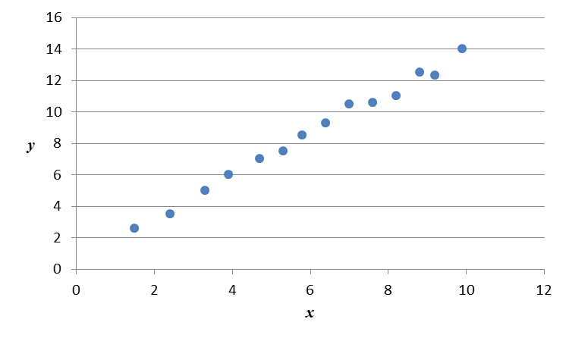

Figure 2

How would you determine the straight line equation that describes the relationship between the two variables? Explain.